EVALUATION OF IN-STORE SHOPPING SYSTEMS AT REFORMATION, COVENT GARDEN
Word Count = 4999


Introduction 3
Rich Picture 5
Rationale for Case Study 6
Aims and Objectives 6
Soft Systems Methodology (SSM) 7
Soft Systems Methodology Results 7
Advantages and Disadvantages of Soft Systems Methodology: 10
Accessibility Tests 10
Colour/Contrast Test 11
Image Alternative Text Test 11
Zoom 11
Colour/Contrast Test Results: 11
Image Alternative Text Test Results: 12
Zoom Test Results 12
Advantages and Disadvantages of Accessibility Tests 13
CLIENTS: 13
PROBLEM: 14
System Usability Scale (SUS) 14
SUS Results 14
Heuristic Evaluation 15
Retail specific Heuristic Evaluation to Reformation Covent Garden’s shop floor application 16
RESULTS OF HEURISTIC EVALUATION: 16
Advantages and Disadvantages of Heuristic Evaluation 18
Interview as methodology 18
The role of interview 19
How we conducted the interview 19
Participant Responses and what we learn 20
Conclusion 22
Bibliography 22

Introduction
Retail shopping has become a huge part of world economies. In the UK, retail accounted for £110.4 billion in 2023, which is 4.7% of the UK's total output (UK Parliament, 2024). Yet over the centuries, there has been little to no technological change in the way retail shopping is done in-person especially in clothing retailers.
Recently, consumers have moved more towards online shopping to avoid having to expend energy and time searching for products in a physical environment (Begole et. al, 2009). Some shoppers still prefer the physical shopping in person as they can try on clothes and interact with highly trained salespeople providing memorable customer service. However, there has been little to no change in the fitting room experience which is commonly a small changing space with a mirror and unsuitable lighting that customers must keep queueing to enter holding their selection. Stores like Reformation have started innovating in interactive fitting room and shop floor applications which are marketed as smart, AI-driven systems for their customers to use year-round.
Human-computer interaction (HCI) is contingent on usability and accessibility, allowing the user to have a smooth experience while shopping in person with software applications. It is important for retail stores to focus on fitting room technology as it is a large reason customers prefer in-store shopping. Customers expect the same ease of usability within a physical retail store as in other non-retail applications (Obermeier & Auinger, 2019). The retail industry has not yet exploited the technological efficiencies and advances that have proliferated in the 21st century. It remains behind the manufacturing industry (which is part of the retail supply chain) despite today’s manufacturing processes exploiting automation technology and data driven cost cutting efficiencies (Kalla, et al. 2024).
With this problem space in mind, this study will use human computer interaction methodologies to evaluate the usability of the fitting room and shop floor applications at Reformation, a female-only sustainable and high-end international clothing store in Covent Garden. Reformation is changing the retail experience by creating a more efficient, software driven shopping environment. This environment allows the customer to be in control of their own shopping experience and time. “Reformation launched in 2009, during the explosion of direct-to-consumer brands and ecommerce growth. Its focus on bringing sustainable fashion to everyone while maintaining profitability has allowed Reformation to endure and grow” (Poe 2024). Reformation understands that fitting rooms are places where customers make decisions to buy clothing and seek to make the customer’s experience easier and more personalized (Yun, et. Al, 2015).

Rich Picture
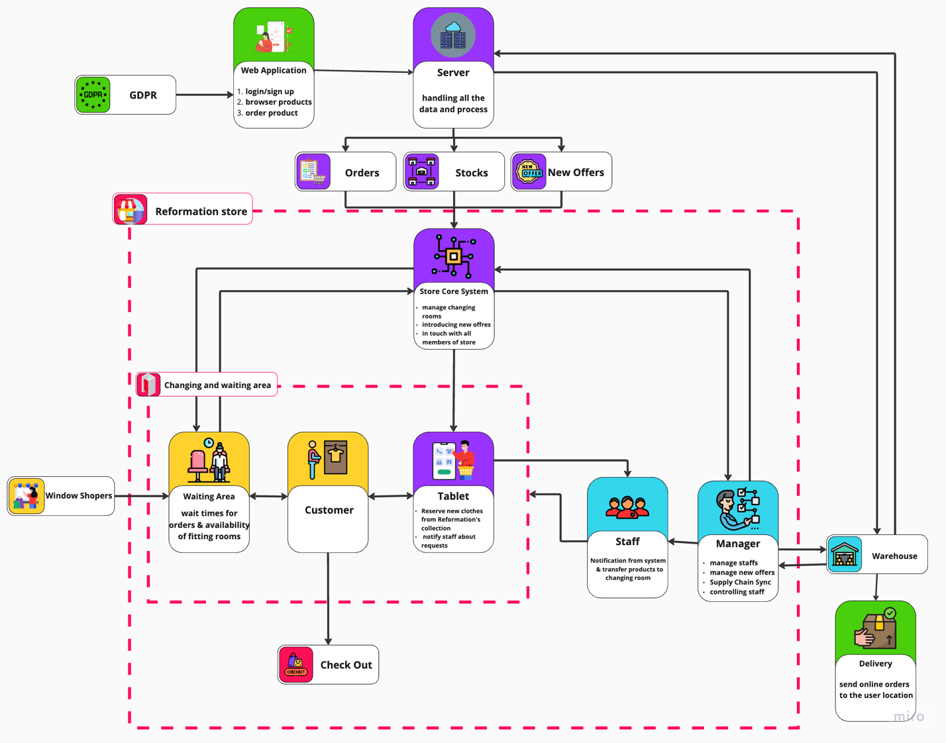
Figure 1: Integrating physical shopping experiences, business operations, and system interactions. Four key perspectives define the process: Physical Customers (Yellow), Business Operations (Blue), and the Server Backbone (Purple).
The journey starts with instore customers accessing the instore shop floor application, where they browse products and select their clothes choices to be tried on in the smart fitting rooms. The system processes these orders and forwards the client’s name and shopping choices to the staff who source the items on the customer’s behalf.

Customers are then notified of the waiting times before being directed to a comfortable waiting area at the back of the store where they can relax with friends and family. The staff then deliver the products to the client’s fitting room before clients proceed ensuring a seamless fitting room experience. While in the changing room they can browse and select more items using a fitting tablet. These clothes will be delivered directly to their changing room without the client leaving. For items that require additional time to be sourced or prepared, customers are notified and can stay in the cubicle or in the waiting area again.

This streamlined process minimizes interaction and tedious searching for clothes in store while ensuring that the shop floor is uncluttered with stock since most stock is selected on the tablets. After trying on their selections, customers can proceed to the checkout area to finalize their purchases.

Rationale for Case Study
Reformation emphasises the need to stay ahead of competitors in their sustainability goals and keeping their target groups in mind (Poe, S. 2024). Reformation has implemented their store to act as an uncluttered, airy, showroom only showing one of each item within the store’s main area and keeping almost all stock in the stock room. Customers can select items they want to try on through an instore iPad or with a worker carrying their own smart device making shopping feel personal. A previous study looking at the fitting room experience, found that, “70% of the respondents believed that a personalized experience would encourage them to make more purchases in the future…These personalized experiences could come from service, advice/recommendations, and offers” (Kronheim, 1872). In utilizing the personalized dressing rooms, Reformation can allow the customer to have a controlled and relaxing shopping experience that can lead to more sales for Reformation. This study investigates Reformation and the way their smart-fitting rooms work to understand how similar smart and personalized technology can be applied to other retail stores.

Aims and Objectives
To critically evaluate the usability of the in-store shopping systems at Reformation, Covent Garden through HCI methodologies and peer-reviewed research. The scope of the assessment will be limited to the two in-store shopping apps (A) on the shop floor and (B) in the changing rooms which are both marketed as smart AI-powered shopping experiences. The evaluation will be conducted by:

1) Applying Soft Systems Methodology to both user interfaces.
2) Applying Accessibility Testing to both user interfaces.
3) Applying the System Usability Scale to both user interfaces.
4) Applying Heuristic Evaluations to both user interfaces.
5) Suggesting improvements in the application in accordance with established literature in the field.
6) To critically evaluate the benefits and disadvantages of the methodologies above that will be used to evaluate.
7) To gather feedback from the public through interviews on their appetite for AI-powered retail systems like Reformation’s.

Soft Systems Methodology (SSM)
Soft Systems Methodology (SSM) is a way of thinking and further understanding a certain issue. SSM does not seek to find an answer to the problem, but rather, learn more about said problem. “SSM provides a framework for tackling such situations” (Institute for Manufacturing, 2024).
SSM consists of seven stages. Stages one and two are both focused on identifying the problem situation and then building a rich picture around the identified problem. Stage three moves into root definitions. “Root definitions are used to identify what the system’s purpose is, who the interested parties are” (Dogan & Henshaw, 2010). To form the root definitions SSM uses the acronym ‘CATWOE’ as a guide. CATWOE stands for customer, actors, transformation, worldview, owners, and environment which refer to elements outside the system taken as a given. (Checkland, 2003). SSM does not just focus on the problem itself but, it builds the background into why it’s a problem, which is why “A distinguishing feature of SSM is its attempt to deal explicitly with the subjective, social, and "political" aspects of business system requirements” (Taylor et. Al, 1998). Stage four of SSM builds a conceptual model for each of the root definitions. The conceptual models state how the system would function overall using arrows and numbered bubbles containing each activity. Stage five consists of comparing the problem to the real world and opening a debate around changes for the future while also comparing the conceptual models with the problem stated in the first two stages. Lastly, stages six and seven carry out the changes to be applied. SSM is a methodology which acts more as a discussion to help learn more about an area and investigate the problems to be changed in the future. “SSM can help to reduce problems such as those above by ensuring that all the different views and needs are discussed and hopefully resolved prior to identifying the detailed development or maintenance requirements” (Taylor et. Al 1998).

Soft Systems Methodology Results
The implementation of SSM to the systemsd at Reformation revealed some critical insights into their technology and store setup, taking into consideration the cultural systems relevant to Reformation’s customers and humanity (Checkland & Scholes 1990, Dogan & Henshaw 2010). The rich picture created in the first two stages of analysis depicts the complex network at Reformation which is made up of the servers and core systems, customers, retail employees, and stock warehouse. It goes into more depth on how customers shop and into more detail about Reformation’s smart fitting room. Arrows direct how retail employees place clothing into the fitting room so that it is ready when the customer arrives, and details are provided that show the changing room tablet located within the fitting room works if more clothes need to be ordered to the fitting room. Reformation relies heavily on having back store stock since their store acts as a showroom with only one of each item. This can be difficult for many people because some choose their sizes by how they align with their bodies visually. Having to use the system by Reformation, where they are to choose their potential size, can be a hindrance for some people.

Using the CATWOE analysis the main elements of the system were broken down and clarified:
C.A.T.W.O.E | Brief Description
Customers (C) | Women that value sustainable and high-quality fashion wanting a seamless shopping experience.
Actors (A) | - Reformation staff members and managers.  - The development teams building Reformation’s in-store core systems and ensuring they run smoothly.  - Contractors in the supply chain.
Transformation (T) | The customer’s ability to have a seamless time-saving and personalized shopping experience.
Worldview (W) | Reformation's goal is to stay ahead of competitors through time-saving shopping and sustainable clothing.
Owners (O) | - CEO Hali Borenstein  - Yael Aflalo  - Private investors
Environmental (E) | - Customer fashion trends  - Technology Limitations.  - High-quality materials and manufacturers.  - Governing laws on; Sunday trading business hours, GDPR, overtime work opt-in contracts, minimum wages for staff including the voluntary London living wage Reformation can opt for and the right to return items that are faulty.

The transformation section brought up problems within Reformation’s fitting room system. With the showroom set up, it was easy to find clothes to try on, however, when going to use the system to try clothes on it was not as time-saving since the customer has to scroll through all of the available items to find the certain item to try on instead of searching and filtering. With the analysis of the worldview, Reformation is ahead of competitors through the implementation of ‘smart fitting rooms’ with digital interfaces. They can keep to their goal of sustainability, by reducing excess clothing in stores and not being a fast fashion brand. However, the digital tablet interface can be seen as unsustainable since it uses energy and is an extra digital device that exists within each dressing room. Reformation’s sustainability ethic monitors their environmental impact. In 2019, 60%-65% of sales were dresses, but with the pandemic, there was less need for or occasion to wear dresses and more need for athleisure. Reformation brand leaders considered entering the athleisure space, but they found no existing fabric on the market met the brand’s sustainability standards (Poe, 2024).

Within the rich picture, the conceptual model was created. Arrows point to how the overall system of Reformation works; including outside factors, which are placed outside store/fitting room squares.

The last section of the SSM analysis investigated areas of improvement for Reformation’s human-computer interaction regarding the store setup and fitting room digital interface. The ability to select items to try on before arriving in store is recommended. This would allow the customer to immediately walk in store and go straight into their dressing room that already contains the clothes they selected beforehand. Implementing AI prompts into the overall fitting room system to have size recommendations would benefit customers. Reformation already provides in-store wait timelines within their screens to track when clothes are arriving in the dressing room. It would be beneficial for Reformation to implement this similar technology through an app on customer’s phones. With this, customers will be able to continue shopping through the store, and they would be notified when their dressing rooms are ready rather than waiting in the figure room area. For the future, these changes would be beneficial to Reformation’s overall values to create a sustainable business that can fund itself and future expansion, while still maintaining high-quality fashion for customers who expect a seamless and time-saving shopping experience.

Advantages and Disadvantages of Soft Systems Methodology
Soft systems methodology is an advantageous HCI methodology as it can help to reduce problems such as those above by ensuring that all the different views and needs are discussed and hopefully resolved prior to identifying the detailed development or maintenance requirements. SSM provides easy to follow steps to create an overall structure for the problem. SSM pushes the researcher to create multiple iterations within their study to further refine their work by exploring different perspectives to improve the problem space (Reaiche. & Papavasiliou, 2022).

However, using Soft Systems Methodology as an HCI methodology can be a disadvantage because, as a researcher, you are not able to make changes to the problem but instead need to make a strong case to the stakeholders involved in the problem and convince them to apply your changes which can be difficult. SSM explores a deeper understanding of the problem through creating a framework rather than finding a solution for the problem. This pulls SSM away from being a definitive technique that can compare solutions to the real world (University of Missouri–St. Louis, no date).

Accessibility Tests
With the current state of the world becoming digitized it is important to focus on making online applications accessible to those with disabilities such as blindness, low vision, or colour blindness. 15% of the world experience disabilities and barriers in regular life (Eler et. al 20). Each website within the UK must adhere to the Web Content Accessibility Guidelines (WCAG) 2.2 AA standard (UK Government, 2024) which provides simple checks to see if a website is accessible for those with certain disabilities. The W3C (2024) easy checks are made up of common checks and audio/visual checks. The common checks include image alternative text, page title, headings, colour contrast, skip link, visible keyboard focus, the language of the page, and zoom. The audio/visual checks include captions, transcripts, and audio descriptions.

Colour/Contrast Test
Within the UK there are an estimated 3 million people with colour blindness, which creates a duty for website developers to consider when creating their systems (Colour blind awareness). Colour and contrast are the first things seen within web content, therefore for those with colour blindness to view the webpage as intended the digital system must adhere to the W3C colour contrast guidelines. “WCAG 2.0 level AA requires a contrast ratio of at least 4.5:1 for normal text and 3:1 for large text. WCAG 2.1 requires a contrast ratio of at least 3:1 for graphics and user interface components (such as form input borders)” (WebAIM, no date). For the W3C guidelines (2024), the system must be visually functional when implementing a grayscale on the platform. The colour/contrast test will be applied to Reformation’s instore devices that are used to select an item and join the queue for a fitting room.

Image Alternative Text Test
Image alternative text is an important resource for those who are visually impaired or have difficulty understanding the text (Jung et. al, 2022). Users of the system can use image alternative text on digital screens to describe on-screen information, use text-to-speech to engage commands to magnify the screen and have information read aloud (W3C, 2024). Reformation being a clothing brand needs to have the availability of image alternative text so the user can be fully independent in their shopping experience. Many visually impaired people have turned toward online shopping as it limits the challenges of instore shopping (Alluqmani et. al, 2023).

Zoom
Globally 2.2 million people have a visual impairment which evokes a strong need for the ability to zoom in on digital systems (WHO, 2023). Zoom allows people to enlarge the text and other elements as needed for their visual impairment. However, with the zoom function, it is necessary to ensure the functionality of the webpage does not change significantly on how the words and images lie within the page (Knowledge Base, Indiana University, 2024). The smart-fitting room screens at Reformation contain words and sizes so for those visually impaired it is important to have the option to zoom in.

Colour/Contrast Test Results:
Through implementing the HCI colour/contrast test on Reformation’s in-store smart-fitting room devices the colour/contrast test failed according to the W3C guidelines (2024). There was no way to change the screen to create a grayscale colour theme. However, Reformation has a minimalistic black and white format to its digital in-store system. The white background and black text, as seen in Figure 2, is preferred among those who are colour blind as it creates a good colour contrast to read (RNIB).
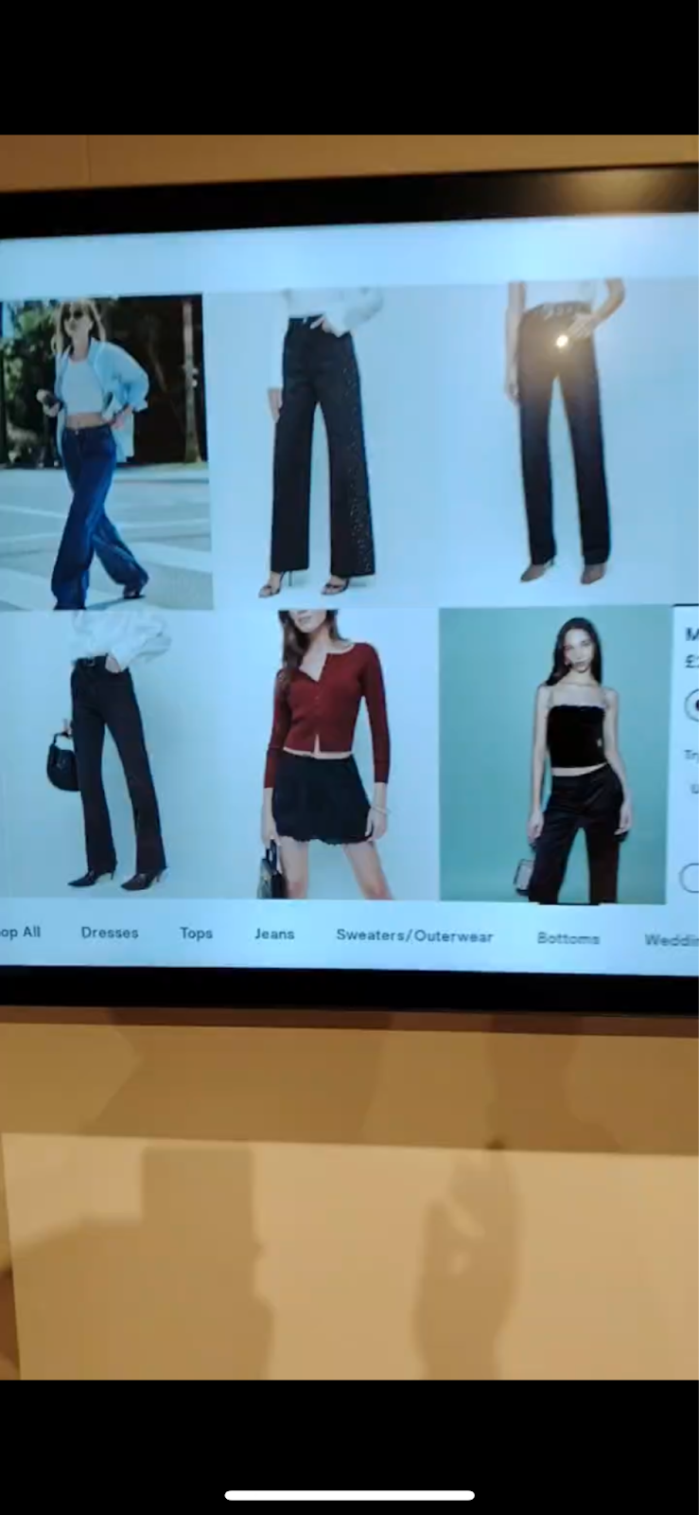
Figure 2: Reformation colour and contrast for the main screen of in-store fitting room device.

Image Alternative Text Test Results:
The image alternative text test of Reformation’s smart-fitting room digital device failed due to the absence of image alternative text accessibility. There was no ability to turn on text-to-speech through the device. The devices are Apple products and have access to assistive touch which allows the user and workers to customize the system. The assistive touch button can perform actions such as siri, control centre, gestures, volume, and more (Apple Support, 2024), however, these actions are preselected for each device at Reformation. Although the device had access to the control centre of the device as seen in Figure 3, access to Siri was turned off meaning that the voice-activated commands were not able to be performed. For those in need of this assistive technology it would be beneficial to speak to a Reformation employee and select their clothes and fitting room through their personal digital devices.

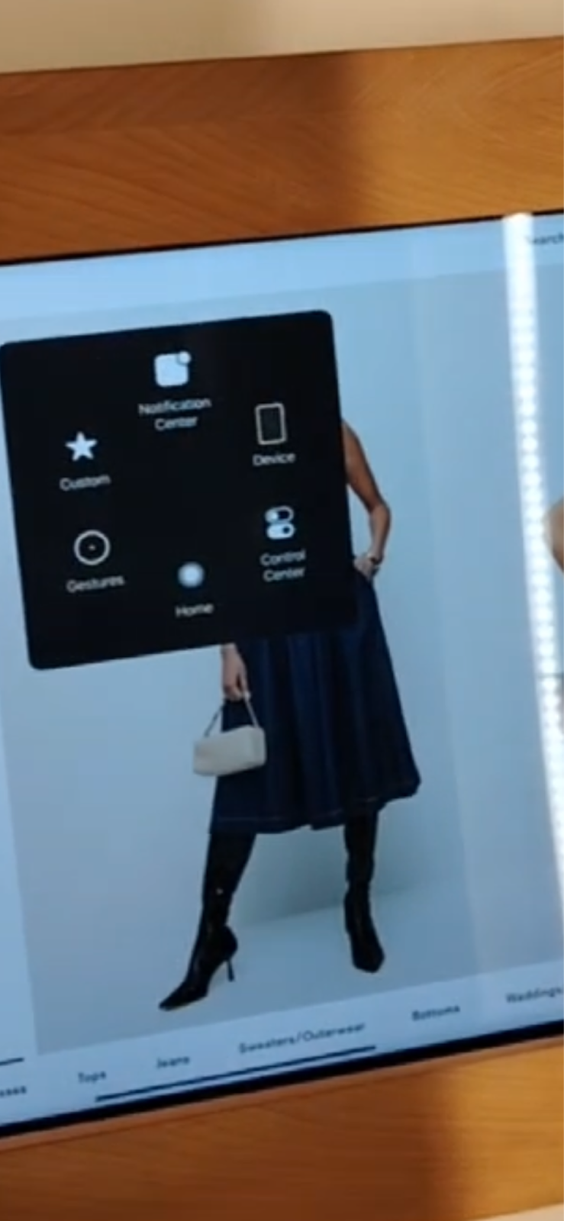
Figure 3: Apple assistive touch on in-store Reformation smart-fitting room device.

Zoom Test Results
The zoom test provided insight into the overall formatting of the website. It was found that button sizes were appropriate size to the W3C guidelines (2024) which are 24x24 pixels (W3C). The button size test was conducted through the online website since it contains the same setup as the in-store digital system, as seen in Figure 4. A 24x24 pixel cursor bookmarklet (Roselli, 2024) was used to measure the button sizes on the website. All button sizes were adherent to the W3C guidelines (2024) however, they were occasionally difficult to select what was needed when physically shopping. The control centre within the device had no option to zoom in on anything. For people with visual impairments using the Reformation digital devices would be difficult as there is no accessibility to change the setup.

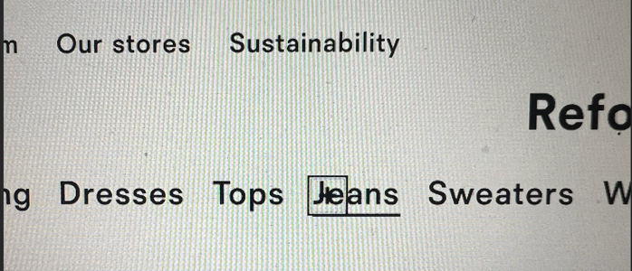
Figure 4: W3C 24x24 button size test using bookmarklet cursor within the online Reformation server.

Advantages and Disadvantages of Accessibility Tests
Accessibility tests help companies meet legal standards set through W3C (2024) within the WCAG international guidelines. Through the European Accessibility Act (EAA) companies are required to create a more inclusive digital interface that permits those with disabilities to have an independent shopping experience without the help of others (Khan, 2024). Conducting accessibility tests benefits companies by enabling them to reach a wider audience, which expands their user base and increases revenue. This is significant as accessibility issues have resulted in an estimated £120 billion in lost sales (Khan, 2024). Conducting accessibility might be disadvantageous due to the complexity of the possible scenarios. For companies, it is hard to plan for every potential situation dealing with disabilities which can become costly for the company. When implementing changes after accessibility tests are complete, it can be hard for companies to ensure that the content on the digital interface still has a logical flow of the content (University of Minnesota Duluth, no date).

System Usability Scale (SUS)
Evaluating the user experience of an application has been a main topic within tech as it can lead to better product development (Cheng et. al, 2021) and another method is through The System Usability Scale (SUS). SUS is a 10-question questionnaire used to measure application usability based on the evaluator's selected tasks (Nasyiah, Kelana, & Riskinato, 2024). The questions are shown to each participant and answered using an agree-to-disagree scale ranging from 0-5. The numbers are tabulated, and a score is created. The questions and results are attached.

SUS Results
The System Usability Scale (SUS) results for Reformation’s in-store smart-fitting room system display a variety of UX issues across different tasks. Task 2 and Task 4 achieved high usability scores, indicating that these features are particularly user-friendly. Conversely, Task 5, finding out more about a product, shows lower scores, suggesting it is difficult for users to interact with it. Tasks 1 and 3 reveal mixed results, with some participants finding it easier to call for help and send orders to another changing room than others. Overall, the SUS results suggest a positive user experience. However, Reformation’s app needs research to examine why some users struggle.
The value in the graphs presented in Figure 5 depicts the combined sum for the 10 questions for the five tasks from four different participants. The last chart compares the total results of all tasks with each other:
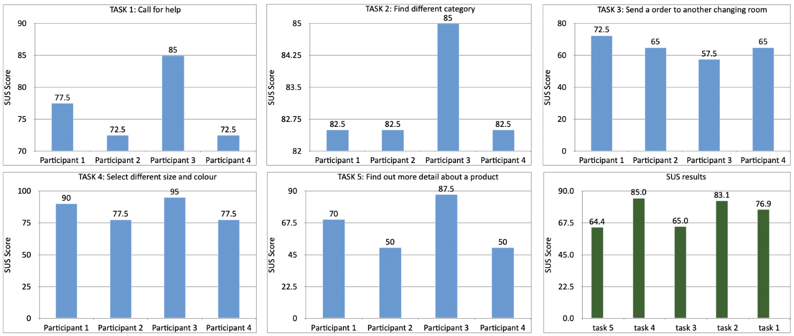
Figure 5: SUS score results for tasks using Reformation’s in-store smart fitting room system.

Heuristic Evaluation
Heuristic Evaluation is a usability engineering method for finding usability problems in a user interface design so that they can be attended to as part of the iterative design process (Nielsen, 1994). According to Nielsen, these usability problems can be found by involving multiple evaluators. Typically, these heuristics are judged against ten principles of good usability design which are:
1) Visibility of system status i.e. users should always be aware of what is going on inside the system.
2) Match between system and the real world i.e. The system’s design, concepts, and actions should be familiar and consistent with a user’s expectations of the real world. Language and interaction pattern that users are accustomed to in their everyday experiences.
3) User control and freedom i.e. Users require control over the system and should be enabled to easily undo actions or exit undesirable states.
4) Consistency and standards i.e. Maintaining consistency within the application, omnichannel, or brand is as important as adhering to established conventions and industry practices.
5) Error prevention; Prevention is more significant than providing effective error messaging alone.
6) Recognition rather than recall: Allowing users to recognize with cues, prompts, clear labels and any other methods which enables the user to identify their clear course of action.
7) Flexibility and efficiency of use; Effective design caters to both novice and expert users so that the new users can easily navigate through the app.
8) Aesthetic and minimalist design; the user interface should be uncluttered and provide a form of hierarchy.
9) Help users recognize, diagnose and recover from errors; the error messages should be clearly spelt out.
10) Help and documentation; there should be tutorials and help for users of the application even if the system is easy to follow.

Retail specific Heuristic Evaluation to Reformation Covent Garden’s shop floor application
In addition to the above set of Heuristics, Reformation’s shop floor application indicates how long the wait will be for the customer’s chosen clothes to be delivered. The waiting time criteria is important for customers at Reformation to decide if they want to stay in store for the fitting or if they will prefer an alternative item already on shelves.

RESULTS OF HEURISTIC EVALUATION
- Reformation’s shop floor application makes it easy for users to know what’s going on inside the application with interactive buttons and clear writing as demonstrated in Figure 6.

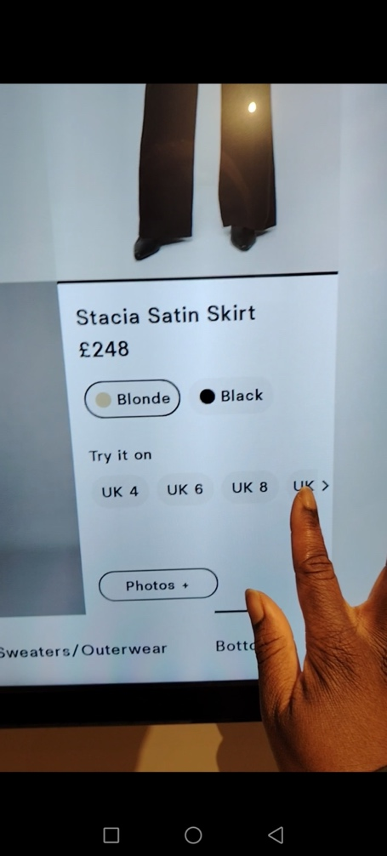
Figure 6: Selecting a size to try on
- Reformation’s shop floor app meets what users will expect in the real world as demonstrated in Figure 7. The users expect a personalised shopping experience and expect their clothes selection to be brought to them in the changing room. This is what they experience with the Salmon coloured window below which asks for their name and to select either a new fitting room or an existing fitting room.
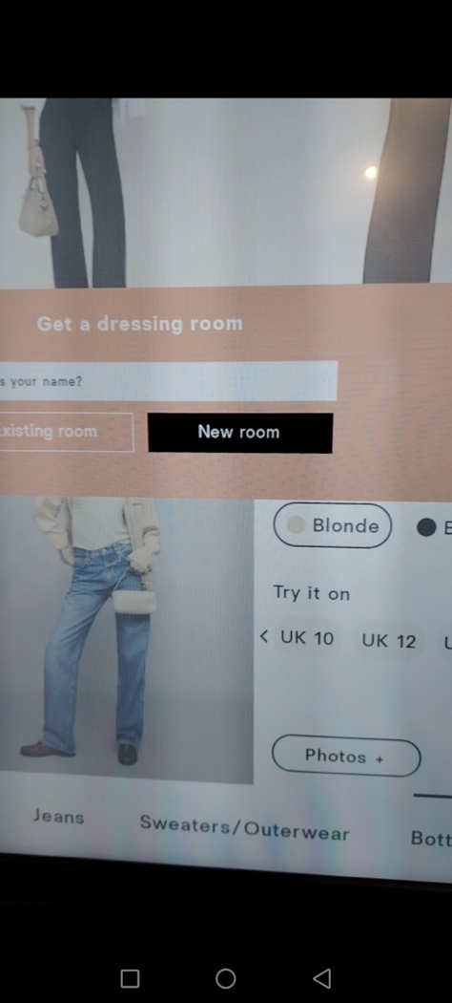
Figure 7: Entering name for fitting room

Figure 8: Selecting an item through the catalog
- The shopper has control and freedom over what the tablet displays and whether they go back to select more clothes or keep the current selection. A shopper also has the option of choosing categories of clothes i.e. Tops, Jeans, Sweater/Outerwear or Blouses as demonstrated in Figure 8.

- There is consistency between the app from its home page and from the various category windows.
5) The current error prevention measures in the store as witnessed by me is that the staff at Reformation can demonstrate the app’s usage entirely.

Advantages and Disadvantages of Heuristic Evaluation
One of the criticisms of Heuristics in peer-reviewed research is that they are not wholistic enough. For example, some of the disadvantages of Nielsen's heuristics are that they are too general and not sufficiently comprehensive. Some authors mentioned that a better performance in Nielsen's heuristics could depend on the evaluator's experience. On the other hand, the authors listed that the advantage of heuristics that new or adapted proposals of heuristics have major potential for discovering more specific usability problems because of incorporation of specific features in each application domain” (Jimenez et al. 2016).
Heuristic evaluation is advantageous as it requires few participants (Talero-Sarmiento et. al, 2024). Using heuristic evaluation provides instant results for usability issues, in which evaluators can make future updates. However, heuristic evaluation is disadvantageous because with fewer participants and expertise of evaluators, bias can be created while also limiting user perspectives (Braithwaite, 2024). This can therefore lead to critical usability issues being missed.

Interview as methodology
Interviewing is a powerful methodology that helps researchers achieve their goals and gather information efficiently when targeted precisely and conducted correctly. According to Seidman (2013); “Interviewing is most consistent with people’s ability to make meaning through language. It affirms the importance of the individual without denigrating the possibility of community and collaboration.” Furthermore, phenomenological interviewing allows researchers to delve deeply into participants’ experiences and understand the depth of personal narratives embedded in their lives. (Seidman, 2013). This historical continuity of interviews highlights the role of interviews in qualitative research, emphasizing their significance in uncovering rich, detailed understandings of human experiences.

Participant Responses and What We Learn
The interviews with four diverse participants shed light on the strengths, challenges, and untapped opportunities for the proposed reservation app providing virtual try-on. Each conversation revealed unique insights, blending practical realities with aspirational possibilities, and providing a rich canvas for reflection.

The first participant, representing a charity shop, highlighted the incompatibility of the system with their unpredictable inventory of unique, donated items. Their feedback underscores a critical limitation: businesses dealing with one-of-a-kind or boutique products may find the system impractical for maintaining customer satisfaction. However, this challenge could also serve as a learning point for tailoring the system to support niche products by emphasizing exclusivity and enhancing customer trust in stock availability.

The second participant, operating a customer service-oriented retail business, brought forward a strong emphasis on human connection. While they appreciated the app’s potential for efficiency, they viewed face-to-face interactions as essential for creating meaningful customer experiences, particularly for significant life events like weddings. This raises an important balancing act: leveraging technology to enhance—not replace—the personal touches that define premium brands.

The third participant, a seasoned retailer with decades of experience, offered a deep dive into operational nuances. They highlighted sizing inconsistencies as a manufacturing flaw that even advanced AI struggles to address. Yet, their openness to future technologies, such as body scanners, reflects a willingness to adapt. Their insights reinforced the importance of blending human expertise with digital tools to create a more precise and tailored shopping experience.

The final participant showcased a unique perspective by identifying trends among younger customers as a hidden opportunity. While they viewed trends as a potential downside, this feedback reveals a chance for the system to harness the power of trends to create a dynamic and engaging experience for modern consumers. Their recognition of virtual try-ons as “interesting” but non-revolutionary highlights a practical mindset, showing cautious optimism toward innovation.

Reflecting on these perspectives, it becomes clear that the success of the proposed system hinges on its adaptability to diverse retail environments. By addressing challenges such as sizing inconsistencies, stock unpredictability, and the need for human connection, while capitalizing on opportunities like trends and personalization, the system can position itself as a transformative tool. The true strength of this project lies in its potential to bridge the gap between the physical and digital worlds, offering a future where technology and human experience work hand in hand to redefine retail.

Conclusion
Through this paper’s application of HCI’s established methodologies, we discovered that Reformation’s applications don’t have much accessibility for those with disabilities. In making their smart fitting rooms more accessible and inclusive, they will increase their sales and profits as they will reach a new demographic. As Reformation strives to stay ahead of competitors, they need to evolve their shopping experience.

Reformation can expand their shop floor and fitting room systems to work outside the store. This allows customers to book a fitting room before entering the store with their clothes selection waiting for them. However, Reformation must re-implement their AI algorithm so as not to neglect customers in-store also waiting. Currently at Reformation, once a dressing room is booked the customer is automatically entered into the queue, which does not update even if the customer leaves the store without trying on their item.

Bibliography
9 Fitting Room Challenges in Stores (2024). Shaku. Available at: https://shaku.tech/en/blogs/blog/9-fitting-room-challenges-in-stores (Accessed: 14 November 2024).
Alluqmani, A., Harvey, M.A. and Zhang, Z. (2023). ‘The barriers to online clothing websites for visually impaired people: An interview and observation approach to understanding needs’, Proceedings of the 2023 ACM Designing Interactive Systems Conference, pp. 753–764. doi:10.1145/3563657.3595978.
AmberLianneWilson (2023). May 5. Available at: https://www.tiktok.com/@amberliannewilson/video/7367047862737292576 (Accessed: 14 Nov. 2024).
Apple Support, (2024). Use Assistivetouch on iPad. Available at: https://support.apple.com/en-gb/guide/ipad/ipad9a2466d3/ipados (Accessed: 15 January 2025).
Babaei, E. et al. (2024). Should we use the NASA-TLX in HCI? A review of theoretical and methodological issues around mental workload measurement. doi:10.2139/ssrn.4869368.
Begole, B. et al. (2009). ‘Designed to fit: Challenges of interaction design for clothes fitting room technologies’, Lecture Notes in Computer Science, pp. 448–457. doi:10.1007/978-3-642-02583-9_49.
Braithwaite, L. (no date) Heuristic evaluation, The Decision Lab. Available at: https://thedecisionlab.com/reference-guide/design/heuristic-evaluation (Accessed: 15 January 2025).
Checkland, P. (2014). Soft systems methodology in action. John Wiley & Sons.
Cheng, F. et al. (2021) ‘User experience evaluation method based on online product reviews’, Journal of Intelligent &amp; Fuzzy Systems, 41(1), pp. 1791–1805. doi:10.3233/jifs-210564.
Colour Blind Awareness (2022) About colour blindness, Colour Blind Awareness. Available at: https://www.colourblindawareness.org/colour-blindness/#:~:text=Colour%20(color)%20blindness%20(colour,and%201%20in%20200%20women. (Accessed: 15 January 2025).
Gasson, S. (2013). Susan Gasson associate professor, Information Systems, Susan Gasson, Academic Home Page. Available at: https://cci.drexel.edu/faculty/sgasson/SSM/Process.html (Accessed: 3 January 2025).
Institute for Manufacturing, University of Cambridge (no date). Soft Systems Methodology. Available at: https://www.ifm.eng.cam.ac.uk/research/dstools/soft-systems-methodology/ (Accessed: 3 January 2025).
International Organization for Standardization (ISO) (2018). ISO 9241-11:2018, “Ergonomics of human-system interaction — Part 11: Usability: Definitions and Concepts”
C. Jimenez, P. Lozada and P. Rosas, "Usability heuristics: A systematic review," 2016 IEEE 11th Colombian Computing Conference (CCC), Popayan, Colombia, 2016, pp. 1-8, doi: 10.1109/ColumbianCC.2016.7750805.
Johnson, J. (2010). Designing with the Mind in Mind. Elsevier. Chapter 1, p1
Jung, C. et al. (2021). ‘Communicating visualizations without visuals: Investigation of visualization alternative text for people with visual impairments’, IEEE Transactions on Visualization and Computer Graphics, 28(1), pp. 1095–1105. doi:10.1109/tvcg.2021.3114846.
Khan, A. (2024) Council post: The importance of accessibility testing for full digital inclusion, Forbes. Available at: https://www.forbes.com/councils/forbestechcouncil/2024/05/31/the-importance-of-accessibility-testing-for-full-digital-inclusion/ (Accessed: 15 January 2025).
Knowledge Base, Indiana University (2024) Check zoom and magnification for web accessibility, Check zoom and magnification for web accessibility - IUKB. Available at: https://servicenow.iu.edu/kb?id=kb_article_view&sysparm_article=KB0026079 (Accessed: 15 January 2025).
Kronheim, A. et al. (2024). ‘The impact of smart fitting rooms on customer experience in fashion retail’, Procedia Computer Science, 239, pp. 1871–1878. doi:10.1016/j.procs.2024.06.369.
Lee, H., Xu, Y. and Porterfield, A. (2020). ‘Consumers’ adoption of AR-based virtual fitting rooms: From the perspective of theory of interactive media effects’, Journal of Fashion Marketing and Management: An International Journal, 25(1), pp. 45–62. doi:10.1108/jfmm-05-2019-0092.
Marcus, A. (2002). ‘Cross-cultural Ui Design’, Proceedings of the conference on Designing interactive systems processes, practices, methods, and techniques - DIS ’02 [Preprint]. doi:10.1145/778772.778774.
Nielsen, J. and Molich, R. (1990). ‘Heuristic evaluation of User Interfaces’, Proceedings of the SIGCHI conference on Human factors in computing systems Empowering people - CHI ’90, pp. 249–256. doi:10.1145/97243.97281.
Norman, D. ‘The Psychology of Everyday Things’ pp. 1, pp.7-9.
Nasyiah, M., Kelana, B., & Riskinato, A. (2024). System Usability Scale for Measuring Usability of Social Network Applications from User Perspectives. Available at: https://bournemouth.on.worldcat.org/oclc/10138442814 .
Obermeier, G. and Auinger, A. (2019). ‘Human-computer interaction in physical retail environments and the impact on customer experience: Systematic literature review and research agenda’, Lecture Notes in Computer Science, pp. 51–66. doi:10.1007/978-3-030-22335-9_4.
Opdenakker, R. (2006). ‘Advantages and Disadvantages of Four Interview Techniques in Qualitative Research’, p. 5, lines 10-20.
Poe, S. (2024). How reformation sticks to its mission and stays ahead of the pack, NRF. Available at: https://nrf.com/blog/how-reformation-sticks-its-mission-and-stays-ahead-pack (Accessed: 12 January 2025).
Pulakos, E. D. (2004). Structured Interviews: Moving Beyond Mean Validity. American Psychological Association. p. 346.
Reaiche, C. and Papavasiliou, S. (2022). Soft systems methodology, Management Methods for Complex Projects. Available at: https://jcu.pressbooks.pub/pmmethods/chapter/soft-systems-methodology/#:~:text=Disadvantages%20of%20SSM,be%20narrowed%20down%20too%20early (Accessed: 14 January 2025).
RNIB (2020). Colour and contrast for people with sight loss. Available at: https://media.rnib.org.uk/documents/Colour_and_contrast_for_people_with_sight_loss_2020.pdf (Accessed: 15 January 2025).
Roselli, A. (2024). 24×24 pixel cursor bookmarklet, Adrian Roselli. Available at: https://adrianroselli.com/2022/05/24x24-pixel-cursor-bookmarklet.html (Accessed: 15 January 2025).
Sites-reformation-US-site (no date). reformation. Available at: https://www.thereformation.com/circularity.html (Accessed: 14 January 2025).
Seidman, I. (2012). Interviewing as Qualitative Research, Chapter 1, New York: Teachers College Press, p. 7-8.
Seidman, I. (2013). ‘A Structure for In-Depth Phenomenological Interviewing’, in Interviewing as Qualitative Research: A Guide for Researchers in Education and the Social Sciences, pp. 14-15.
Seidman, I. (2013). ‘Why Interview?’, in Interviewing as Qualitative Research: A Guide for Researchers in Education and the Social Sciences, pp. 7-13.
Seidman, M. (2021). European Journal of Cardiovascular Nursing, p. 392.
Taeb, M. et al. (2024). ‘AXNAV: Replaying accessibility tests from natural language’, Proceedings of the CHI Conference on Human Factors in Computing Systems, pp. 1–16. doi:10.1145/3613904.3642777.
Talero-Sarmiento, L. et al. (2024) Towards a refined heuristic evaluation: Incorporating hierarchical analysis for weighted usability assessment [Preprint]. doi:10.20944/preprints202404.0848.v2.
Taylor, M.J., Moynihan, E.P. and Wood-Harper, A.T. (1998). “Soft Systems Methodology and Systems Maintenance,” Systemic Practice and Action Research, 11(4), pp. 419–434. Available at: https://doi.org/10.1023/A:1023034508238.
University of Minnesota Duluth (no date). Strengths and Limitations of Automated Tools, Strengths and limitations of Automated Tools. Available at: https://www.d.umn.edu/itss/training/online/wave/strengths_limits.html (Accessed: 15 January 2025).
University of Missouri–St. Louis (no date). A Look at Soft Systems Methodology. Available at: https://www.umsl.edu/~sauterv/analysis/F2015/Soft%20Systems%20Methodology.html.htm#nine (Accessed: 14 January 2025).
W3C (WAI), W.W.A.I. (2024). Easy checks – a first review of web accessibility, Web Accessibility Initiative (WAI). Available at: https://www.w3.org/WAI/test-evaluate/easy-checks/ (Accessed: 15 January 2025).
Ward, M. (2024). Retail sector in the UK, Retail Sector in the UK. Available at: https://researchbriefings.files.parliament.uk/documents/SN06186/SN06186.pdf (Accessed: 12 January 2025).
WebAIM (no date). Contrast checker, WebAIM. Available at: https://webaim.org/resources/contrastchecker/ (Accessed: 15 January 2025).
WHO (2023). Vision Impairment and blindness, World Health Organization. Available at: https://www.who.int/news-room/fact-sheets/detail/blindness-and-visual-impairment#:~:text=Globally%2C%20at%20least%202.2%20billion,near%20or%20distance%20vision%20impairment. (Accessed: 15 January 2025).
Yu, J., Xie, J. and Lu, H. (2024). ‘Virtual fitting room technology: Unleashing the transformative potential for fashion brands’ Retail Operational Performance’, Asia Pacific Journal of Marketing and Logistics [Preprint]. doi:10.1108/apjml-06-2024-0844.
Yu, W. and Ramanathan, R. (2008). "An assessment of operational efficiencies in the UK retail sector", International Journal of Retail & Distribution Management, Vol. 36 No. 11, pp. 861-882. https://doi.org/10.1108/09590550810911656
Yun, S.J., Jung, H.I. and Choo, H.J. (2015). “Consumer experiences in fitting rooms in SPA stores,” Fashion and Textiles : International Journal of Interdisciplinary Research, 2(1), pp. 1–14. Available at: https://doi.org/10.1186/s40691-015-0044-7.

